Name: | Index No.: | CT Group: 09

PIONEER JUNIOR COLLEGE, SINGAPORE

JC 2 PRELIMINARY EXAMINATION 2010
HIGHER 1

CHEMISTRY 8872/02

Paper 2 21 SEPTEMBER 2010

2 hours
Candidates answer Section A on the Question Paper

Additional Materials: Answer Paper
Data Booklet

READ THESE INSTRUCTONS FIRST

Write your Centre number, index number and name on all work you hand in.
Write in dark blue or black pen on both sides of the paper.
You may use a soft pencil for any diagrams, graphs or rough workings.
Do not use staples, paper clips, highlighters, glue or correction fluid.

Section A
Answer all the questions

Section B
Answer two questions on separate answer paper

You are reminded of the need for good English and clear presentation in your answers.

At then end of the examination, fasten all your work securely together.
The number of marks is given in brackets [ ] at the end of each question or part question.

FOR EXAMINER’S USE
PAPER 1 | SECTION A |  | SECTION B
/ 30 | 1 | / 16 | 4 | / 20
/ 30 | 2 | / 14 | 5 | / 20
/ 30 | 3 | / 10 | 6 | / 20
/ 30 | TOTAL | / 40 | TOTAL | / 40
PERCENTAGE |  | / 100 | GRADE

This document consists of 14 printed pages.

Pioneer Junior College

Section A

Answer all questions in this section
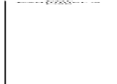
1 | This question is about elements and their compounds in period 3.
 | (a) | Both magnesium and phosphorus can form chlorides. Magnesium chloride, MgCl₂, has a melting point of 714 ºC. Phosphorus (III) chloride, PCl₃, a trigonal pyramidal molecule, can react further with chlorine to form phosphorus (V) chloride, PCl₅, a trigonal bipyramidal molecule.
 |  | (i) | Construct dot-and-cross diagram for magnesium chloride:
 |  | (ii) | Magnesium oxide has a melting point of 2852 °C. Explain why magnesium oxide has a higher melting point than magnesium chloride.  ionic bond strength ∝ 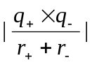 (1/2 mark )  Since charge of O²⁻ , q₋, in MgO is greater than Cl⁻ in MgCl₂  (1/2 mark )  ionic radius of O²⁻ , r₋ is smaller than ionic radius of Cl⁻, (1/2 mark )  Hence MgO has stronger ionic bonds, more energy to break  (1/2 mark )  Hence higher melting point.  [3]
 | (b) | (i) | Explain why PCl₃ is not a trigonar planar molecule using the valence shell electron pair repulsion theory.  Phosphorus atom in PCl₃ contains three regions of bonding electrons and one lone pair. ( 1 mark )  Hence there is additional bond pair lone pair repulsion (1/2 mark) which is greater than bond pair bond pair repulsion that exists in a regular trigonal planar molecule. ( ½ mark ). Hence the observed shape for water molecule is trigonal pyramidal.
 |  | (ii) | Explain why PCl₅ can exist but not MgCl₅ ?  Phosphorus can expand its octet as it has available 3d orbitals to be be used for covalent bonding with 5 other chlorine atoms. ( 1 mark )  For ionic compound, MgCl₅ to exist, it requires large amount of  energy ( 1 mark) to remove 5 electrons from Magnesium to form Mg⁵⁺ in  MgCl₅.  [4]
When PCl₅ dissolves in water, it hydrolyses in water to produce hydrochloric acid, HCl(aq) and phosphoric acid, H₃PO₄(aq) with a pH = 1

When aluminum chloride is dissolved in water, it also hydrolyses in water to produce an acidic solution.

Both acidic solutions produced from the reaction of PCl₅ and AlCl₃ with water can react with sodium carbonate to give carbon dioxide gas.

 | (c) | (i) | Write a balanced equation to show the reaction between PCl₅ and water.  PCl₅ + 4 H₂O → 5 HCl(aq) + H₃PO₄ (aq) ( 1 mark )
 |  | (ii) | Explain using equation(s) why aluminium chloride reacts with water to produce an acidic solution ?  Al³⁺ has high charge density. [1] It can polarise the O-H bond in water molecules causing them to break. [1/2 mark]  H₃O ⁺ is released hence the solution is acidic. [1/2 mark]  [Al(H₂O)₆]³⁺ + H₂O [Al(H₂O)₅OH]²⁺ + H₃O ⁺ (1 mark)
 |  | (iii) | The aqueous chlorides of the period 3 element give different pH.  Write down the pH of the aqueous chlorides in the table provided  ( 2 marks for this question (- ½ mark for each wrong answer) )
   | aqueous NaCl | aqueous MgCl₂ | aqueous AlCl₃ | aqueous SiCl₄ | aqueous PCl₃
  pH | 7 | 6-6.5 | 3 | 1-2 | 1-2
 |  | (iv) | Construct dot-and-cross diagram of the carbonate anion in sodium carbonate.  [7]  ( 1 mark )
 | (d) | The electrical conductivity of some Period 3 elements is shown below.  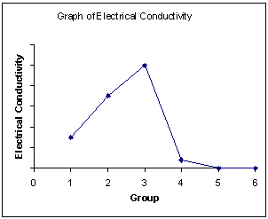  Na Mg Al Si P S
 |  | (ii) | Explain why there is an increasing electrical conductivity from sodium to aluminium?  The number of delocalised valence electrons contributed to the sea of delocalised electrons in the giant lattice structure of metal increased from one in sodium to three in Aluminium. ( 1 mark )
 |  | (iii) | Explain why there is no electrical conductivity for phosphorus and sulfur? [2]  [Total 16]  Phosphorus and Sulfur has a simple molecular structure. (1/2 mark ).There is no free mobile charge carriers, hence unable to conduct electricity (1/2 mark)

2 | For each of the following organic compounds, determine the type of isomerism they exhibit and suggest a simple chemical test to distinguish them, indicating the observations you would see.  For Examiner’s Use
 | (a) | 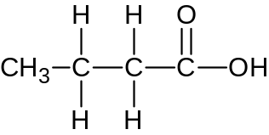  and  butanoic acid  ethyl ethanoate  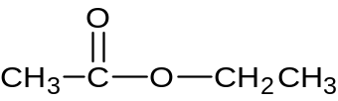
 |  | (i) | Type of isomerism: Functional group isomerism ( 1 mark )
 |  | (ii) | Reagents and conditions: Na₂CO₃(aq) (1 mark)  Observations for butanoic acid:  Effervescence observed, colourless gas evolved forms white precipitate when bubbled into limewater. ( 1/2 mark )  Observations for ethyl ethanoate:  No observable change ( 1/2 mark )  [3]
 | (b) | 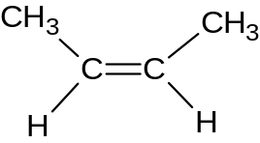  but-2-ene but-1-ene  For Examiner’s Use  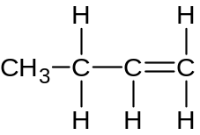
 |  | (i) | Type of isomerism: Positional isomerism ( 1 mark )
 |  | (ii) | Reagents and conditions: KMnO₄(aq), H₂SO₄(aq), heat ( 1 mark )  Observations for but-2-ene:  Purple KMnO₄ solution decolourised. ( 1/2 mark )  Observations for but-1-ene:  Purple KMnO₄ solution decolourised ( 1/2 mark ), effervescence observed, colourless gas evolved which forms white precipitate when bubbled into limewater. ( 1 mark )  [4]
 | (c) | But-2-ene can exhibit other types of isomerism besides the one mentioned in (b)(i)  Draw each isomer belonging to the two other types of isomerism in each of the two boxes shown below.  (i)  (ii)
( 1 mark each )

[2]
 | (d) | The diagram shown below is an energy cycle involving but-1-ene at 25ºC and 1 atmospheric pressure.  For Examiner’s Use  ΔH^{θ}₁  4C(g) + 4H₂(g) CH₃CH₂CH=CH₂ (g)  + 6O₂(g) + 6O₂(g)  ΔH^{θ}₂ ΔH^{θ}₃  4CO₂(g) + 4H₂O(l)
 |  | (i) | Calculate the standard enthalpy change, ΔH^{θ}₁ above using the following bond enthalpies.  ΔH^{θ}₁ = ∑mBE( reactants ) - ∑nBE ( products)  = 4(436) – [2BE(C-C) + 8BE(C-H) + BE(C=C) ]  = [1744) – [2(350) + 8(410) + 610]  = - 2846  = - 2850 kJ mol⁻¹ ( 2 marks ) (wrong sign = no marks)  ( wrong units minus 1 mark )
  Bond | Bond enthalpy / kJ mol⁻¹
  H-H | 436
  C-H | 410
  C-C | 350
  C=C | 610
 |  | (ii) | The standard enthalpy change, ΔH^{θ} ₁ does not represent the standard enthalpy change of formation of but-1-ene. Explain why.  Graphite exists as solid under standard conditions of 298 K and 1 atmospheric pressure but the graphite shown in the question is in the gaseous state. ( 1 mark )
 |  | (iii) | Use the following data below as well as your answer in (d)(i) to calculate the standard enthalpy change of combustion of but-1-ene  For Examiner’s Use  ΔH ^{θ} _{c}( C(g) ) = - 1110 kJ mol⁻¹  ΔH ^{θ} _{c}(H₂) = - 286 kJ mol⁻¹  ΔH^{θ}₃ = ΔH^{θ}_{c}(but-1-ene)  ΔH^{θ}₂ = [4(ΔH ^{θ} _{c}( C(g) ) + 4 ΔH ^{θ} _{c}( H₂ )]  = 4(-1110) + 4(-286)  = - 5584 kJ mol⁻¹ (1 mark )  By Hess’ law  ΔH^{θ}₁ + ΔH^{θ}₃ = ΔH^{θ}₂  ΔH^{θ}₃ = ΔH^{θ}_{c}(but-1-ene)  = ΔH^{θ}₂ - ΔH^{θ}₁  = - 5584 – (- 2846 )  = -2738  = - 2740 kJ mol⁻¹ (1 mark )  [5]  [Total: 14]

3 | Apricot kernels contain glycoside amygdalin, an organic compound which turns into deadly hydrogen cyanide acid, HCN, when the kernel is crushed or injured. High doses of hydrogen cyanide can cause coma with seizures and cardiac arrest, leading to death in a matter of minutes. A fatal dose for a human can be as low as 1.50 mg kg⁻¹ of body weight. (1 mg = 1.00 x 10⁻³ g)  For Examiner’s Use  The forensics department of the local law enforcement agency was trying to determine the cause of death of a 75 kg deceased man who was found at home on the couch with a few empty packets of apricot kernels lying on the ground.  A 10 cm³ sample of blood (a typical human has 71 cm³ of blood per kg body mass) obtained from the body and hydrogen cyanide containing haemoglobin was isolated and dissolved to form 25 cm³ of solution. This sample of the haemoglobin was oxidised by potassium dichromate, K₂Cr₂O₇, to determine the amount of Fe²⁺ which is also equal to the amount of hydrogen cyanide present. 1.70 cm³ of 0.00100 mol dm⁻³ acidified K₂Cr₂O₇ solution was required for complete reaction.
 | (a) | Write a redox equation between Fe²⁺ and Cr₂O₇²⁻.  6 Fe²⁺ + Cr₂O₇²⁻ + 14 H⁺ → 6 Fe³⁺ + 2 Cr³⁺ + 7H₂O  [1]
 | (b) | Show by oxidation number that the reaction in (a) is a redox reaction.  The oxidation number of Fe increases from +2 in Fe²⁺ to +3 in Fe³⁺ (1/2 mark ) indicating that Fe undergoes oxidation  The oxidation number of Cr decreases from +6 in Cr₂O₇²⁻ to +3 in Cr³⁺ indicating that Cr undergoes reduction. (1/2 mark )  [1]
 | (c) | Calculate the total amount of hydrogen cyanide, HCN in the 25 cm³ of solution.  Amount of Cr₂O₇²⁻ = (1.70/1000) x (0.00100)  = 1.70 x 10⁻⁶ mol (1 mark )  Amount of Fe²⁺ = 6 x amount of Cr₂O₇²⁻ = 6 x 1.70 x 10⁻⁶  = 1.02 x 10⁻⁵ mol (1 mark )  Hence amount of HCN = 1.02 x 10⁻⁵ mol [2]
 | (d) | Calculate the amount of hydrogen cyanide, HCN, in the body of the deceased man.  For Examiner’s Use  Amount of HCN in the body of the deceased man  = (1.02 x 10⁻⁵ / 10) x 71 x 75  = 5.431 x 10⁻³ mol (1 mark )  [1]
 | (e) | Calculate the concentration of HCN in mg kg⁻¹ and hence determine if the cause of death was due to hydrogen cyanide poisoning.  Mass of HCN = 5.431 x 10⁻³ x ( 1.0 + 12.0 + 14.0)  = 0.1466 g  = 146.6 mg ( 1 mark )  Concentration of HCN in mg kg⁻¹ = 146.6 / 75  = 1.954 mg kg⁻¹ ( ½ mark ) > 1.50 mg kg⁻ ¹  ( ½ mark )  [2]
 | (f) | (i) | Given that the 25 cm³ sample of hydrogen cyanide solution in (c) has a pH of 6.30, show quantitatively that HCN is a weak acid.  [HCN] in the 25 cm³ sample in (c)  = 1.02 x 10⁻⁵ / 0.025  = 4.08 x 10⁻⁴ moldm⁻³ (1/2 mark )  [H⁺] = 10^{-pH} = 10^{-6.30} = 5.01 x 10⁻⁷ moldm⁻³ (1/2 mark)  [H⁺] = 5.01 x 10⁻⁷ mol dm⁻³ < [HCN] = 4.08 x 10⁻⁴ mol dm⁻³  Hence HCN is a weak acid as it does not dissociate completely.  (1/2 mark)
 |  | (ii) | What is the effect of adding universal indicator to this 25 cm³ sample of hydrogen cyanide solution mentioned in (f)(i)?  Universal indicator turns yellow (1/2 mark )  [2]  [2]
 | (g) | Explain why potassium chloride, KCl , cannot be used to oxidise Fe²⁺?  Cl⁻ can only undergo oxidation. ( 1 mark )  [1]  [Total: 10]

Section B

Answer two of the three questions in this section on separate answer paper

4 | An organic compound, E, has the molecular formula C₁₁H₁₄O₂. When E is heated with aqueous HCl, benzoic acid and F with formula C₄H₉OH, is formed. When F is heated with hot Al₂O₃, G, C₄H₈ is produced. Heating G with acidified potassium manganate(VII) produces H, C₃H₆O. H produced an orange precipitate with 2,4-dinitrophenylhydrazine but does not react with Tollens’ reagent.
 | (a) | Draw the structures of compounds E to H and explain the above reactions. Write chemical equations to support your answer. [10]  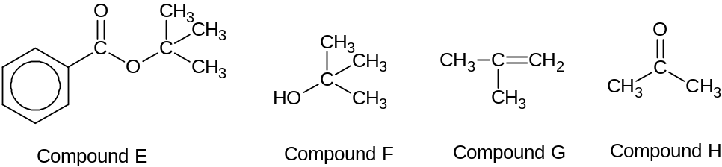  (4 mark)
Clue | Type of reaction | Deduction
Aqueous HCl, heat | Acid Hydrolysis | ester is present
Hot Al₂O₃ | elimination | alcohol eliminated to alkene
Acidic KMnO₄, heat | oxidation | Terminal alkene present
Orange precipitate with 2,4-DNPH | condensation | Carbonyl compound present
Negative Test for Tollen’s Reagent |  | Not aldehyde ( or ketone )

[1/2 each, max 3]
Reaction of ester with hot aqueous hydrochloric acid
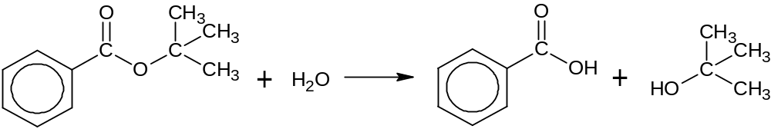

Reaction of Compound F with hot Al₂O₃
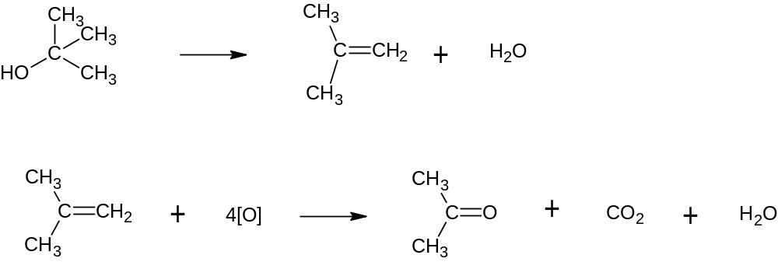

Reaction of Compound G with hot acidic potassium manganate.

Reaction of compound H with 2,4-DNPH

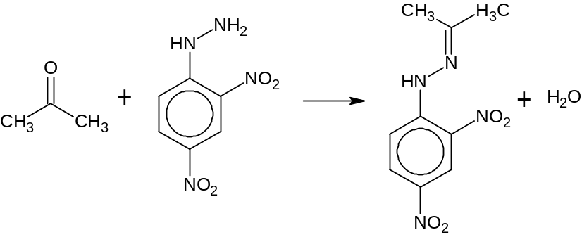(1 mark each, max 3)
1-aminopropan-2-ol is produced from ethanol by the following synthesis pathway.
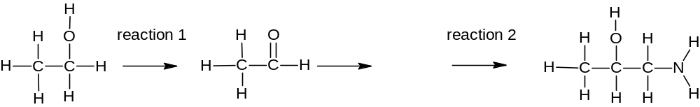

J

1-aminopropan-2-ol
 | (b) | (i) | Draw the displayed formula of compound J.  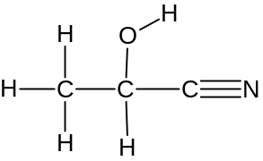 ( 1 mark )  Compound J
 |  | (ii) | Write the reagents and conditions for reactions 1 and 2. [3]  1. K₂Cr₂O₇(aq), H₂SO₄(aq), heat with immediate distillation ( 1 mark)  2. LiAlH₄ in dry ether or H₂, Ni catalyst, 150⁰C ( 1 mark )
 | Alkene is an unsaturated organic compound and undergoes addition. Benzene which is also an unsaturated organic compound undergoes substitution.
 | (c) | Explain why benzene undergoes substitution instead of addition? [2]  To undergo addition, the delocalised π system of benzene must be broken. (1/2 mark )  This process is energetically unfavorable. (1 mark)  hence benzene undergoes substitution where the aromatic character is retained ( 1/2 mark)
 | Chlorofluorocarbons, CFCs, are small alkane molecules where some hydrogen atoms have been substituted by chlorine and fluorine atoms. CFCs are used as aerosol propellant in spray can and as refrigerant. A typical CFC is CH₃CHClF.
 | (d) | (i) | (i) Explain why the synthesis of CH₃CHClF from fluoroethane, CH₃CH₂F and chlorine produces a mixture of products?  The extent and position of substitution of chlorine atom on any H atom cannot be controlled. ( 1 mark )
 |  | (ii) | (i) CH₃CHClF can be converted to CH₃CH(OH)F. Give the reagents and conditions for this reaction.  NaOH(aq), heat ( 1 mark )
 |  | (iii) | - Explain why C-F bond in CFC does not undergo the reaction in (d)(ii)?  The C-F covalent bond is strong ( 1 mark ) hence the energy provided is not high enough to break it.
 |  | (iv) | Why does this CFC present an environmental concern?  CFC molecules will react with O₃ in the ozone layer and deplete it.  ( 1 mark )
 |  | (v) | Suggest one way to reduce the use of CFCs. [5]  Replace CFC with hydrofluorocarbon. ( 1 mark )  [Total: 20]
5 | Sulfuric acid, H₂SO₄, is a strong mineral acid which is an important chemical used in industry and in the school laboratory.  One step in the manufacture of sulfuric acid by the contact process involves the reaction between sulfur dioxide and oxygen.  2 SO₂ (g) + O₂ (g) 2 SO₃ (g)  When 72 dm³ of sulfur dioxide gas and 32.0 g of oxygen gas are reacted in a 27000 dm³ reaction vessel at a constant temperature of 25ºC and 1 atmospheric pressure, the percentage conversion of sulfur trioxide was 80% at equilibrium.
 | (a) | (i) | (i) Calculate the initial amount of sulfur dioxide gas and initial amount of oxygen gas at 25ºC and 1 atmospheric pressure.  Amount of SO₂ initially = 72 / 24 = 3 mol ( 1/2 mark )  Amount of O₂ initially = 32.0 / 2(16.0) = 1 mol ( 1/2 mark )
 |  | (ii) | Explain which reagent is the limiting reagent?  O₂ is the limiting reagent (1/2 mark) since 1 mol of SO₂ should react with 2 mol of SO₂ < 3 mol of SO₂ initially. ( 1/2 mark )
 |  | (iii) | Calculate the equilibrium constant with its units.  2 SO₂ (g) + O₂ (g) 2 SO₃ (g)  Initial amt / mol 3 1 0  Change in amt/ mol 2(-0.8) 1(-0.8) +2(0.8)  Eqm amt/ mol 1.4 0.2 1.6 ( 1 mark)  Eqm [ ] / mol dm⁻² 1.4/27000 0.2/27000 1.6/27000  = 5.185 x 10⁻⁵ = 7.41 x 10⁻⁶ = 5.92 x 10⁻⁵  K_{c} = [SO₃]² / [SO₂]² [O₂]  = (5.92 x 10⁻⁵)² / (5.185 x 10⁻⁵)² (7.41 x 10⁻⁶)  = 17 5920 = 176000 mol⁻¹ dm³  (1 mark, -1/2 mark for unit )
 |  | (iv) | What will happen to the yield of SO₃ (g) when the reversible reaction at equilibrium is conducted at 2 atmospheric pressure?  At a higher pressure of 2 atmospheric pressure, By Le Chatelier’s principle, the position of equilibrium will shift to the right with fewer moles of gas (1mark ) to reduce the pressure.  Hence the yield of SO₃(g) increases. ( 1mark )  [6]
 | (b) | (i) | Sulfuric acid is a dibasic strong acid. Explain the underlined term.  Sulfuric acid donates two protons and dissociates fully.  ( 1 mark ) ( 1 mark )
 |  | (ii) | A 100 cm³ of solution contains 0.980 g of sulfuric acid. Calculate the pH of the sulfuric acid solution.  Amount of sulfuric acid = 0.980 / 2(1.0) + 32.1 + 4(16.0)  = 9.989 x 10⁻³  = 9.99 x 10⁻³ mol (1/2 mark )  [H₂SO₄] = 9.989 x 10⁻³ / (100/1000)  = 9.989 x 10⁻²  = 9.99 x 10⁻² mol dm⁻³ ( ½ mark )  [H⁺] = 2 x 9.989 x 10⁻²  = 1.997 x 10⁻² mol dm⁻³ ( ½ mark )  pH = - log₁₀[H⁺] = - log₁₀(1.997 x 10⁻²) = 0.699 ( ½ mark )  [4]
The titration curve is obtained when sodium hydroxide is added to sulfuric acid. The equivalence point is reached when 25.0 cm³ of sodium hydroxide is added.
pH
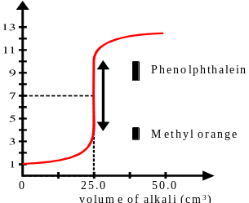

Equivalence pH = 7

Volume of NaOH / cm³

Methyl orange and litmus are suitable indicators to determine the equivalence point of the titration between sulfuric acid and sodium hydroxide solution.
Indicator | Working pH range
Methyl Orange | 3.2 – 4.4 | Colour of methyl orange < pH 3.2 (red) | Colour of methyl orange > pH 4.4 (yellow)
litmus | 6.0 – 8.0 | Colour of litmus  < pH 6.0 (red) | Colour of litmus  > pH 8.0 (blue)

 | (c) | (i) | Explain why methyl orange is a suitable indicator?  The working range of methyl orange fall within the almost vertical section of the titration curve (1 mark )  And there is a distinct colour change from red to yellow at the end points. (1/2 mark )  [3]
 |  | (ii) | Explain why litmus is a suitable indicator?  The working range of litmus of pH 6.0 to 8.0 coincides with the equivalence pH of 7.0 of the titration curve. ( 1 mark )  There is a distinct colour change from red to blue at the end points. (1/2 mark ) [3]
Sulfuric acid is needed in many organic reactions. The reaction scheme below shows the reaction involving sulfuric acid.

M
Concentrated H₂SO₄, CH₃COOH, heat

Excess concentrated H₂SO_{4,}
170ºC

L
H₂SO₄(aq), heat
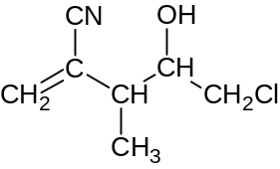

P + Q

+ other minor product(s)
K
Concentrated H₂SO₄, followed by H₂O, warm

N

 | (d) | (i) | Draw the structures of L, M, N. If other products are also produced, draw the major product only.
 |  | (ii) | Draw the structures of P and Q given that P has a higher net dipole moment.  Answer given above ( 1 mark each )
 |  | (iii) | Explain why P has a higher net dipole moment than Q.  P has two electron withdrawing groups ( CN and Cl) on the same side of the C=C group, ( 1 mark ) hence it has a net dipole moment.  Q has two electron withdrawing on opposite side of the C=C group, which will cancel part ( 1 mark ) of the other dipole moment, resulting in a lower dipole moment.  [7]  [Total: 20]

6 | The standard enthalpy change of formation of boron trifluoride between boron solid and fluorine gas to produce gaseous boron trifluoride in a reaction vessel is shown below:  B (s) + 3/2 F₂ (g) BF₃ (g)
 | (a) | With reference to boron trifluoride, define the standard enthalpy change of formation of boron trifluoride, ∆H^{θ}_{f}(BF₃)  The standard enthalpy change of formation of boron trifluoride is the heat change when one mole of boron trifluoride is formed from its constituent boron element and fluorine element under standard conditions of 298 K and 1 atmospheric pressure. ( 1 mark )  [1]
 | The order of reaction with respect to fluorine is one. The half-life of the reaction is 10 days. Given that the initial concentration of fluorine is 0.600 mol dm⁻³.
 | (b) | Sketch a graph of [F₂] against time showing two half-lives in your graph.  [ F₂ ] / moldm⁻³  1 mark for showing correct shape and variables with correct units on axis.  1 mark for showing correct numerical values.  0.600  0  0.300  0.150  [2]
 | (c) | Explain what will happen to the rate of formation of gaseous boron trifluoride
 |  | (i) | when the volume of the reaction vessel is increased ?  when volume of the reaction vessel is increased, [F₂] decrease  ( 1/2 mark) and there will be less effective collisions per unit time (1/2) and the rate of formation will decrease. ( 1 mark )
 |  | (ii) | when a bigger piece of solid boron is used ?  When a bigger piece of solid boron is used, the surface area of boron reactant become larger (1/2 mark) and there will be greater number of effective collisions per unit time.(1/2 mark )  hence the rate of formation will increase ( 1 mark ) [4]
 | A copper catalyst can increase the rate of formation of gaseous boron trifluoride.
 | (d) | (i) | Write the electronic configuration of Copper atom. 1s² 2s² 2p⁶ 3s² 3p⁶ 3d¹⁰ 4s¹ ( 1 mark )
 |  | (ii) | Using relevant diagram, explain how the copper catalyst can increase  the rate of formation of gaseous boron trifluoride [4]  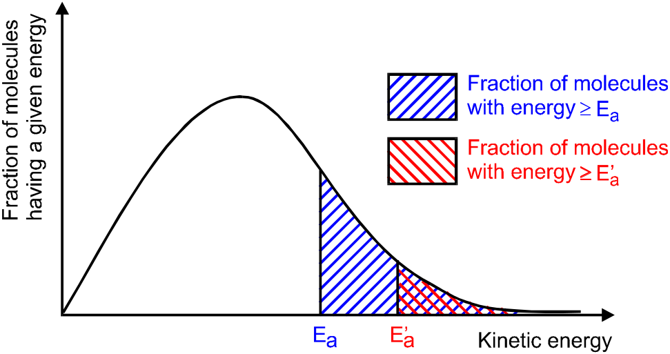  ( 1/2 mark ) for correct axis and correct shape,  ( 1/2 mark ) showing two Ea and legends.  A catalyst provides an alternative pathway with a lower activation energy ( 1/2 mark ) for a reaction to proceed  More particles have kinetic energy greater or equal to the activation energy. ( 1/2 mark )  More effective collisions per unit time ( 1 mark )  the rate of reaction increases.
 | (e) | (i) | Write an equation to represent the first ionisation energy of Boron.  B(g) → B⁺ (g) + e⁻ ( 1 mark )
 |  | (ii) | Boron has a lower first ionisation energy than Beryllium. Explain why.  Be: 1s² 2s² B: 1s² 2s² 2p¹  This is because the 2p electron (1/2 mark ) of boron to be removed is of higher energy (1/2 mark ) than the 2s electron (1/2 mark) of Be as it is more shielded by the additional inner 2s subshell electrons ( 1/2 mark) in B, hence less energy is needed to remove the outermost electron from boron than beryllium.  [3]
 | (f) | (i) | BF₃ reacts with NH₃ to form molecule S. Draw a structure to represent the molecule S. (1 mark)
 |  | (ii) | Explain the criteria for forming the structure you have proposed in (f)(i)  B has 3 valence electrons which are used to form bonds with 3 fluorine atoms. The resulting compound is electron deficient (1 mark). Lone pair of electrons on a neighbouring N atom from NH₃ forms a dative bond (1 mark) with B thus achieving octet.
 |  | (iii) | Show the hydrogen bonding between two molecules of S, showing dipoles and other relevant information. [5]  Show lone pair on F atom, correct dipoles and hydrogen bond ( 2 mark )  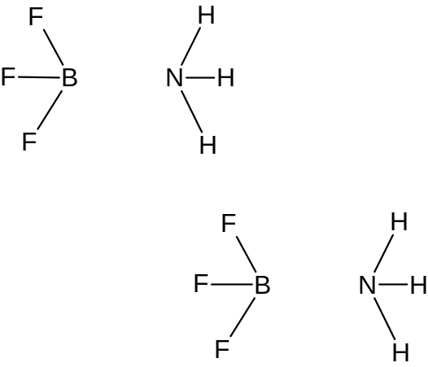
 | BF₃ reacts with water to form a weak acid, boric acid, H₃BO₃ as one of its products. Excess H₃BO₃ reacts with aqueous NaOH to form buffer solution consisting of aqueous H₃BO₃ and aqueous NaH₂BO₃.
 | (g) | Write an ionic equation to show how this buffer solution decreases the acidity when a small amount of acid is added.  H₂BO₃⁻ + H⁺ → H₃BO₃ ( 1 mark ) [1]  [Total: 20]

END OF PAPER

